Firewall

🔥 What is a Firewall Device?
# Source: Chatgpt (GPT‑5 Mini) at [12/18/2025]
A Firewall device is a physical or virtual network security system that monitors, filters, and controls incoming and outgoing network traffic based on predefined security rules. It acts as a barrier between a trusted internal network (like your office or home) and untrusted networks (like the internet).
✅ A firewall’s main job is to allow safe traffic and block harmful or unauthorized traffic.

🔐 What a Firewall Device Does
# Source: Chatgpt (GPT‑5 Mini) at [12/18/2025]
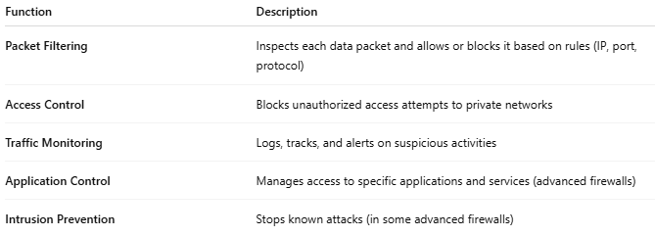

Function | Description
Packet Filtering | Inspects each data packet and allows or blocks it based on rules (IP, port, protocol)
Access Control | Blocks unauthorized access attempts to private networks
Traffic Monitoring | Logs, tracks, and alerts on suspicious activities
Application Control | Manages access to specific applications and services (advanced firewalls)
Intrusion Prevention | Stops known attacks (in some advanced firewalls)

🧱 Where It Sits in a Network
# Source: Chatgpt (GPT‑5 Mini) at [12/18/2025]
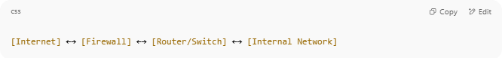
[Internet] ←→ [Firewall] ←→ [Router/Switch] ←→ [Internal Network]

- It protects the internal network from malicious internet traffic.

🧠 Types of Firewall Devices
# Source: Chatgpt (GPT‑5 Mini) at [12/18/2025]
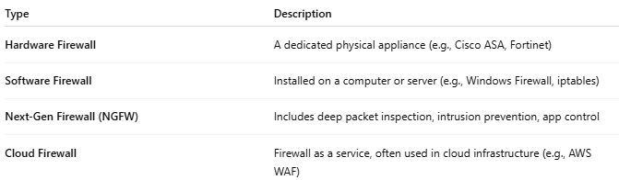

Type | Description
Hardware Firewall | A dedicated physical appliance (e.g., Cisco ASA, Fortinet)
Software Firewall | Installed on a computer or server (e.g., Windows Firewall, iptables)
Next-Gen Firewall (NGFW) | Includes deep packet inspection, intrusion prevention, app control
Cloud Firewall | Firewall as a service, often used in cloud infrastructure (e.g., AWS WAF)

🆚 Router vs Firewall
# Source: Chatgpt (GPT‑5 Mini) at [12/18/2025]
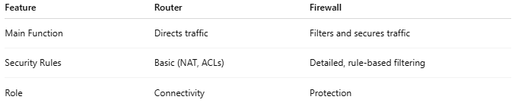

Feature | Router | Firewall
Main Function | Directs traffic | Filters and secures traffic
Security Rules | Basic (NAT, ACLs) | Detailed, rule-based filtering
Role | Connectivity | Protection
📌 Some modern routers have built-in firewall features, especially in home and small business setups.

✅ Pros
# Source: Chatgpt (GPT‑5 Mini) at [12/18/2025]
- ✅ Protects against hacking, malware, unauthorized access
- ✅ Centralized control of network security
- ✅ Customizable traffic rules
- ✅ Logs and alerts for network activity

❌ Cons
# Source: Chatgpt (GPT‑5 Mini) at [12/18/2025]
- ❌ Can block legitimate traffic if misconfigured
- ❌ Hardware firewalls can be expensive
- ❌ Advanced features may require technical knowledge

🔥 Common Firewall Vendors
# Source: Chatgpt (GPT‑5 Mini) at [12/18/2025]
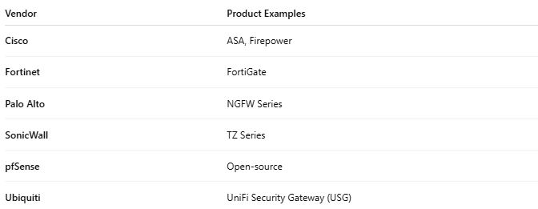

Vendor | Product Examples
Cisco | ASA, Firepower
Fortinet | FortiGate
Palo Alto | NGFW Series
SonicWall | TZ Series
pfSense | Open-source
Ubiquiti | UniFi Security Gateway (USG)

📌 Summary
# Source: Chatgpt (GPT‑5 Mini) at [12/18/2025]
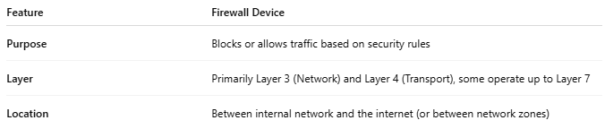

Feature | Firewall Device
Purpose | Blocks or allows traffic based on security rules
Layer | Primarily Layer 3 (Network) and Layer 4 (Transport), some operate up to Layer 7
Location | Between internal network and the internet (or between network zones)

